Matthew Austin

CIS 340: Concepts of Telecommunications and Networking

Instructor: Yi Yang

7 September 2017

Homework #1

1. **What is the OSI reference model? (5 points)**

The OSI or Open Systems Interconnection reference model is a reference model/framework for how computers/applications communicate over a network.

**What is the TCP/IP reference model? (5 points)**

The TCP/IP or Transmission Control Protocol/Internet Protocol is a network model used in the current internet architecture. It contains protocols that that are a set of rules that control or govern every possible communication over a network.

**What are the similarities (10 points) and differences (10 points) between the OSI model and the TCP/IP model?**

*Similarities:*

Both are similar designed as they both have layers.

They both have similar transport and internet/network layers.

Packets may take different route when reaching a destination (client/server).

Both of their transport layers have a reliable byte stream.

*Differences:*

OSI has 7 layers while TCP/IP has 4 layers.

OSI follows a vertical approach while TCP/IP follows a horizontal approach.

OSI provides wired and wireless connection service while TCP/IP is only wireless.

TCP/IP is more reliable than the OSI model.

1. **What is encapsulation?**

encapsulation is the process where each layer of the computer that’s sending data adds its own information, essentially encapsulating the data. The only way for decapsulation is if the receivers layers remove the corresponding layers.

Use Wireshark to observe packet formats and encapsulations on a computer.

Attach screenshots from Wireshark to illustrate encapsulation. (30 points)

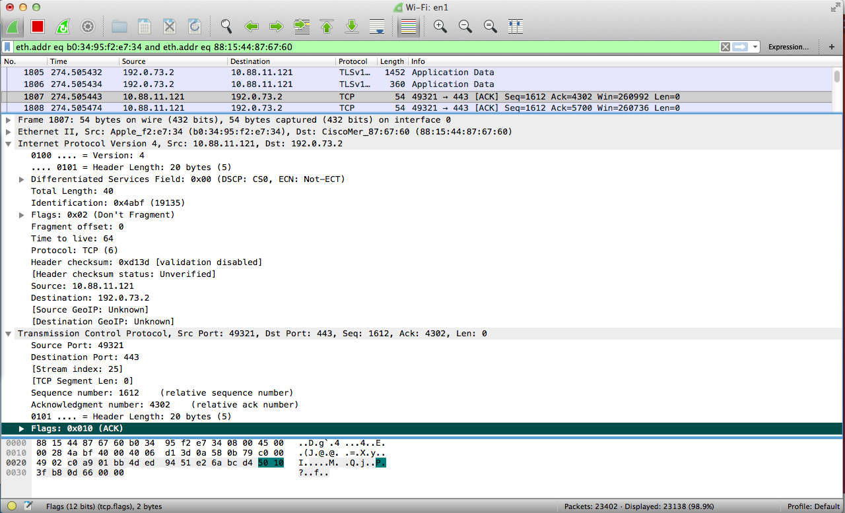

1. Design a computer network for Fontbonne University (topology, devices, etc). Justify your design using words. (30 points)

The topology that I would use for Fontbonne University would be a star topology.

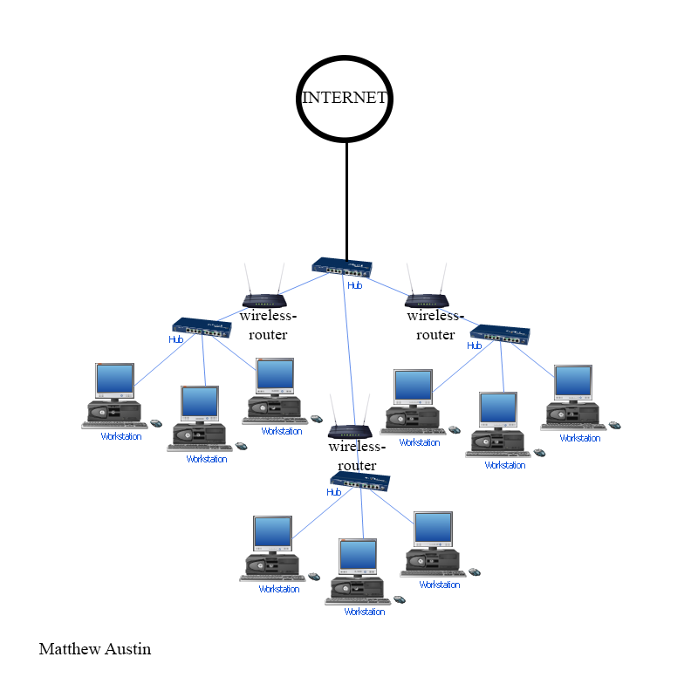

1. Write a summary of the history of computer networks. Please include major events until the year of 2017. (10 points)

In 1969, ARPANET was started by the US Dept. of Defence under U.S. Advanced Research Projects Agency (ARPA) for research into networking. It is the original premise for what now forms the Internet. Early in that same year, was published, the RFCs (network working group, Request For Comment) are a series of papers which are used to develop and define protocols for networking

In 1972, The first international connections to ARPANET are established. In, 1973 the was Ethernet developed, this became a very popular way of connecting PCs and other computers together. A group of machines connected together in this way is known as a LAN.

In 1984, DNS (Domain Name Server) introduced to the Internet, which then consisted of about 1000 hosts. In 1989 World Wide Web, invented by Tim Berners-Lee. The Web is the integration of hypertext and the Internet. In 1995 JavaScript development announced by Netscape. The next year, 1996 Netscape Navigator 2.0 released which was the first browser to support JavaScript.